Write a simple ‘fake’ MP3 player

1. Song information will be stored in a tab-delimited text file
   1. Stored in same directory as main VI
   2. An example file has been provided
   3. Named: Catalog.spx
   4. Format
      1. Artist Name
      2. Album Name
      3. Song Name<tab>Song Length in seconds
      4. Blank Line between entries
   5. Example

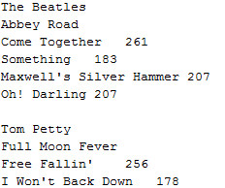

1. Program will read the file in at startup automatically
2. GUI should load in and display information for the first album automatically at startup
3. GUI should also show the following information:
   1. Artist Name
   2. Album
   3. List of songs on the selected album with length
      1. Display length as minutes:seconds (3:26)
   4. Ability to browse through albums in the catalog (only has to show details about one at a time)
   5. Current Playlist
      1. Display Artist, Song and Time Remaining (3:26 format)
      2. There should not be a limit to playlist size (within reason)
      3. Songs should be able to be listed on the playlist more than once
      4. There should be a way to add and remove songs from the playlist (including the one that is currently playing)
4. The first song in the playlist should start playing automatically
   1. The Time Remaining should start at the song length and count down
   2. Updates should be at least once a second
   3. When a song is finished, it should automatically be deleted from the playlist
   4. The next song should start playing automatically
5. Please send the source code as well as a project with a build spec that we can use to build an exe (don’t send the built exe or the attachment will get filtered out by our email).
6. Ask questions